lab 2 - Proof of Concept (POC)
Generated from the provided screenshots and notes.

Lab Solved
enter carlos use and password-12345 and i enter password randomly password is correct so lab solved easily
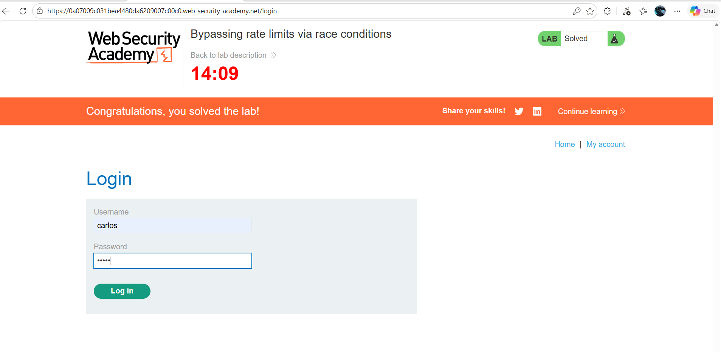

Lab Solved
lab solved
